FUNCTION f_countries WILL ACLCULATE THE TOTAL RECORDS OF COUNTRIES TABLE.

THE PL\SQL PROGRAM( countries_f) WILL DEMONSTRATE THE USE OF FUNCTION.

CODE :

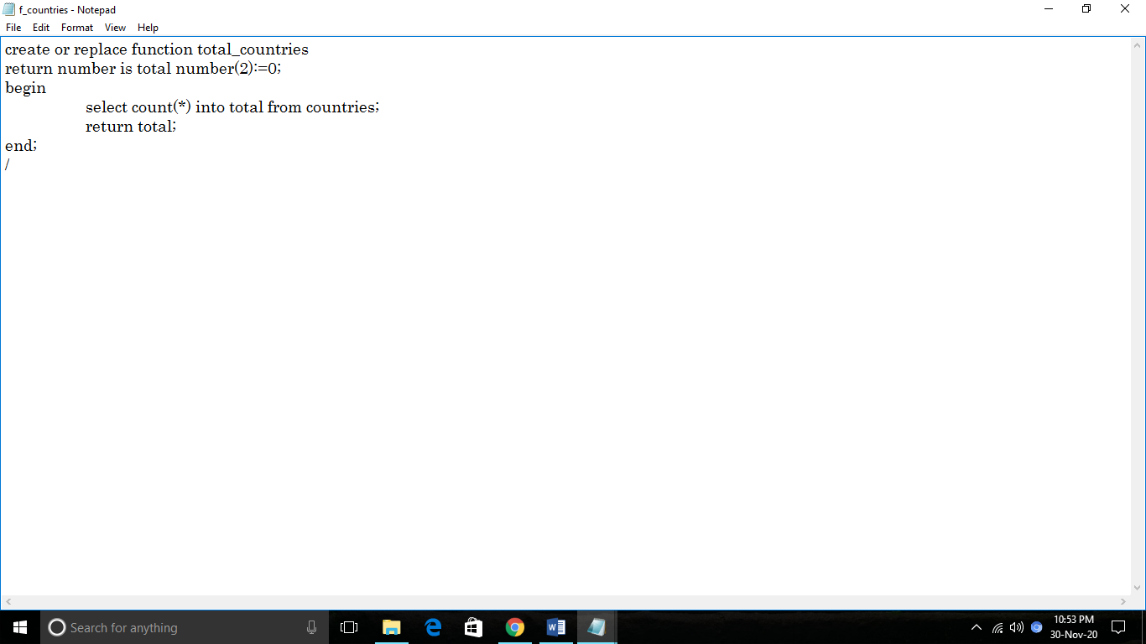

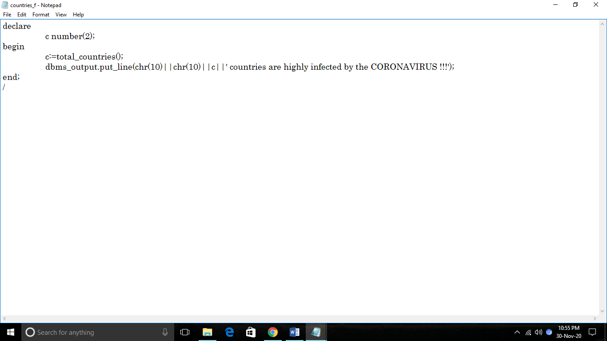

OUTPUT :

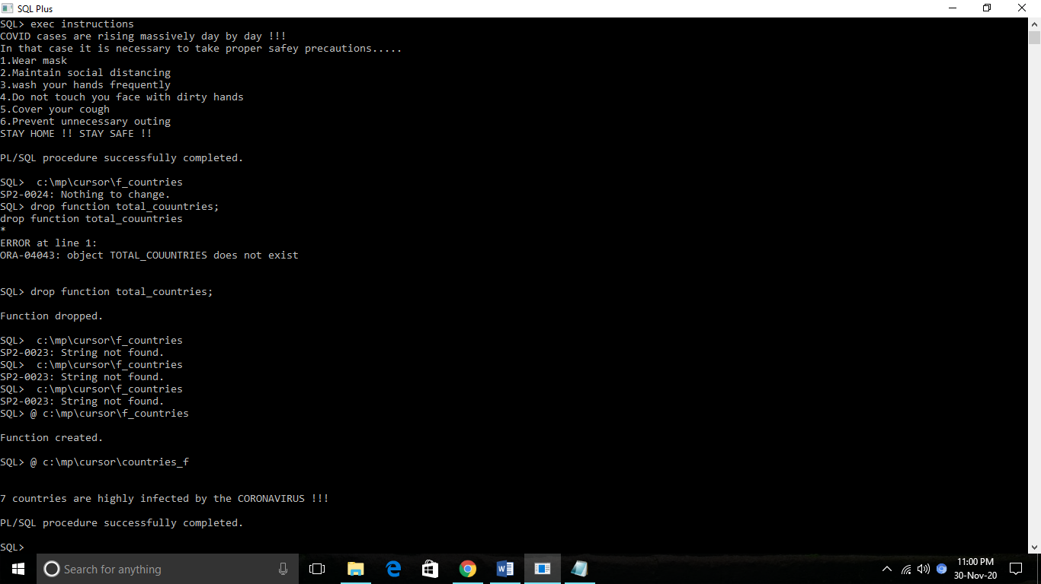

CREATE A CURSOR THAT WILL SHOW THE RECORD OF TOP 7 INFECTED COUNTRIES

CODE :

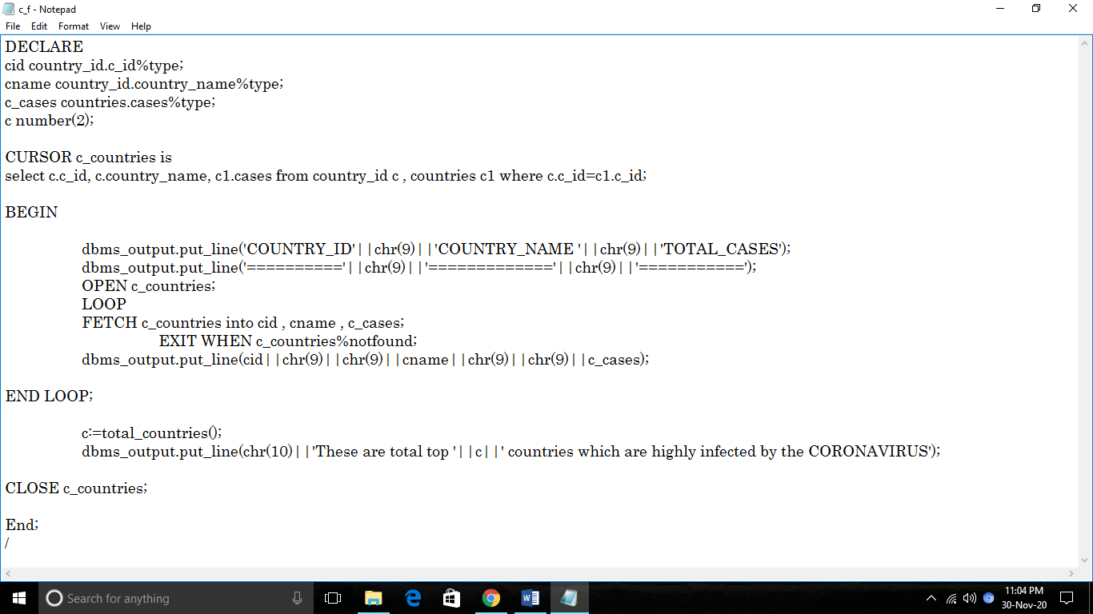

OUTPUT :

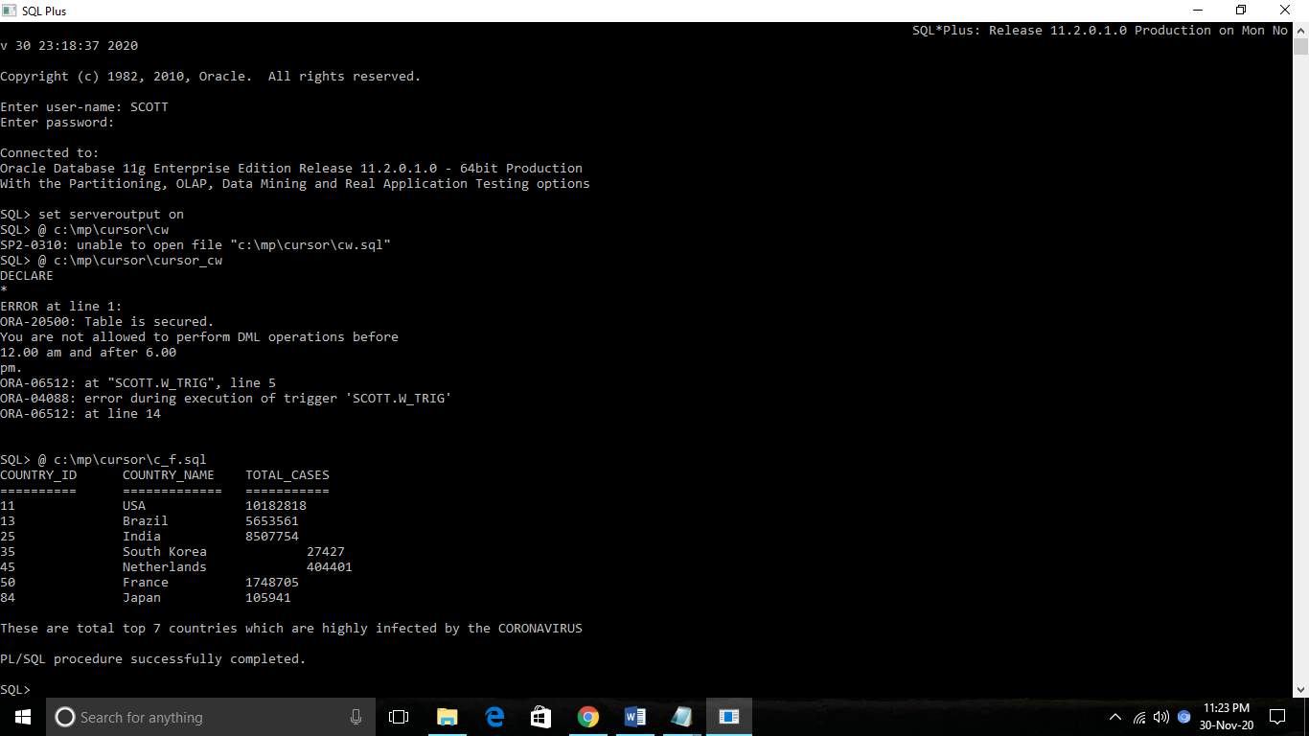

CREATE A CURSOR THAT WILL DISPLAY THE RECORDS OF COUNTRIES TABLE USING **CHR()** FUNCTION.

CODE :

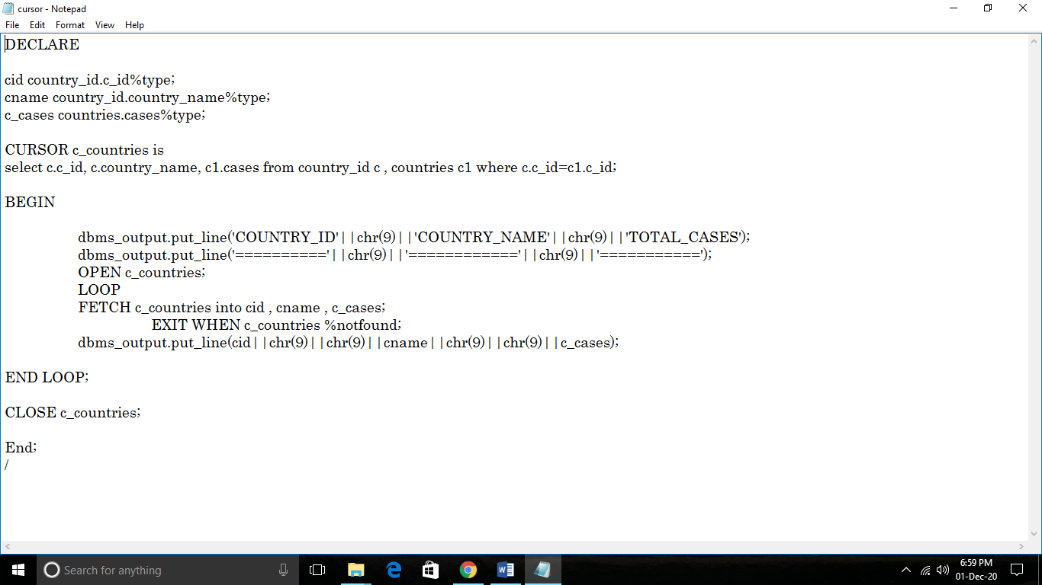

OUTPUT :

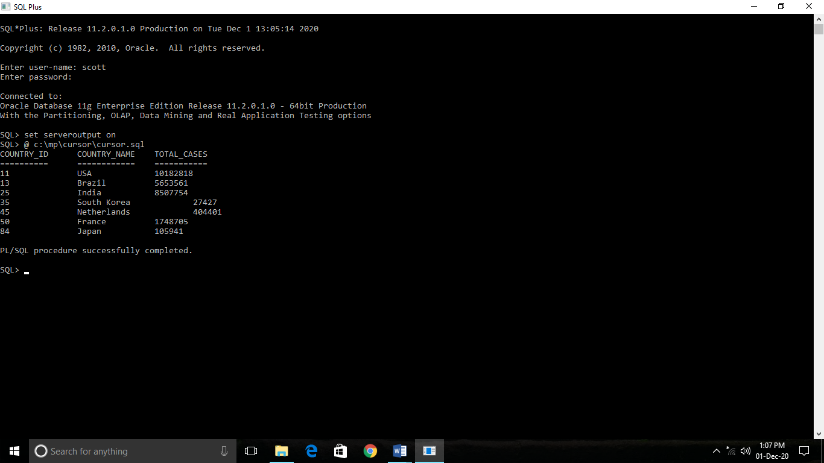

CREATE A CURSOR THAT WILL UPDATE THE CASES IN COUNTRIES TABLE AS WELL AS IN WORLD TABLE.

CODE :

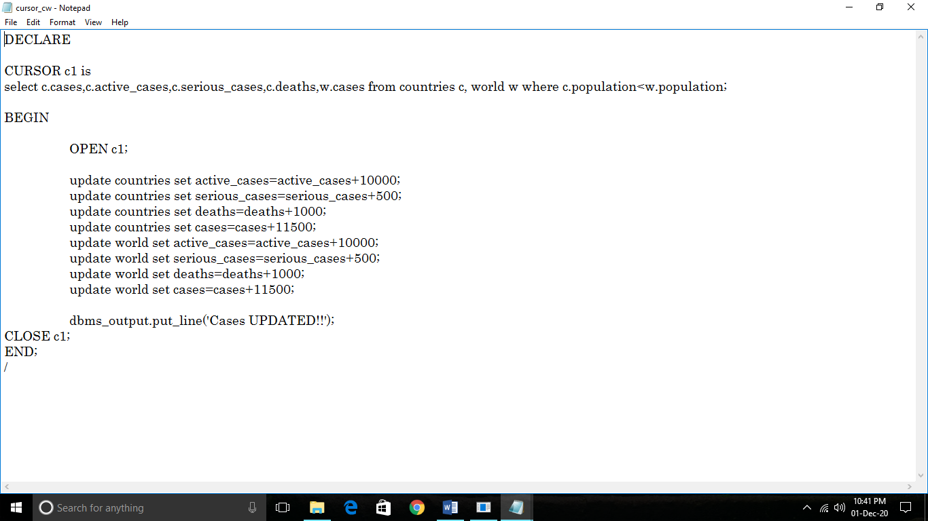

OUTPUT :

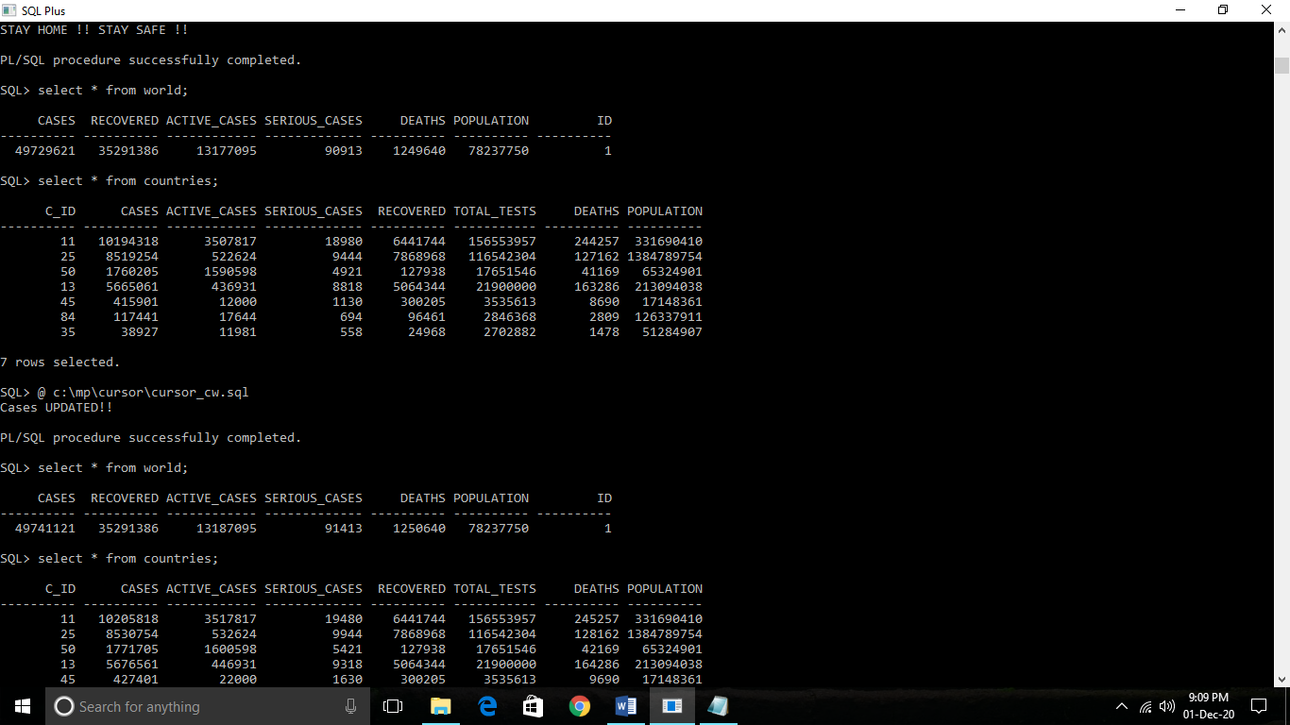

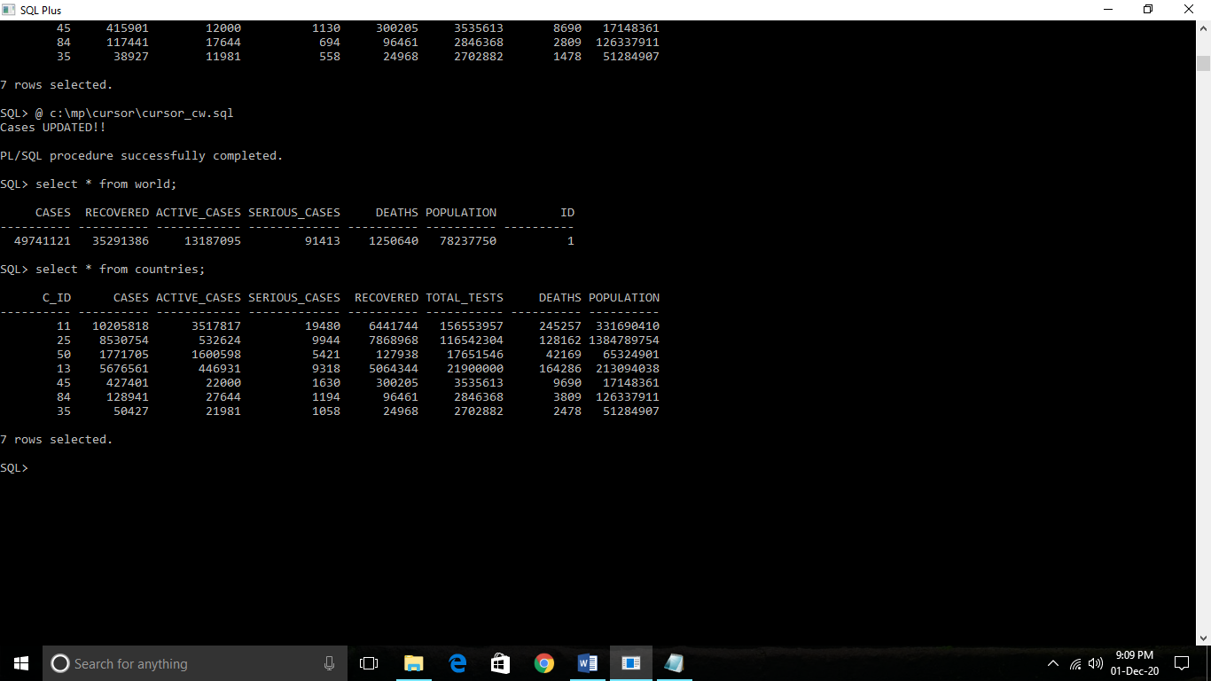

CREATE A TRIGGER ON TABLE vaccine_creation_info THAT WILL GIVE THE INFORMATION ABOUT SUCCESSFUL AND UNSUCCESSFUL VACCINES.

CODE :

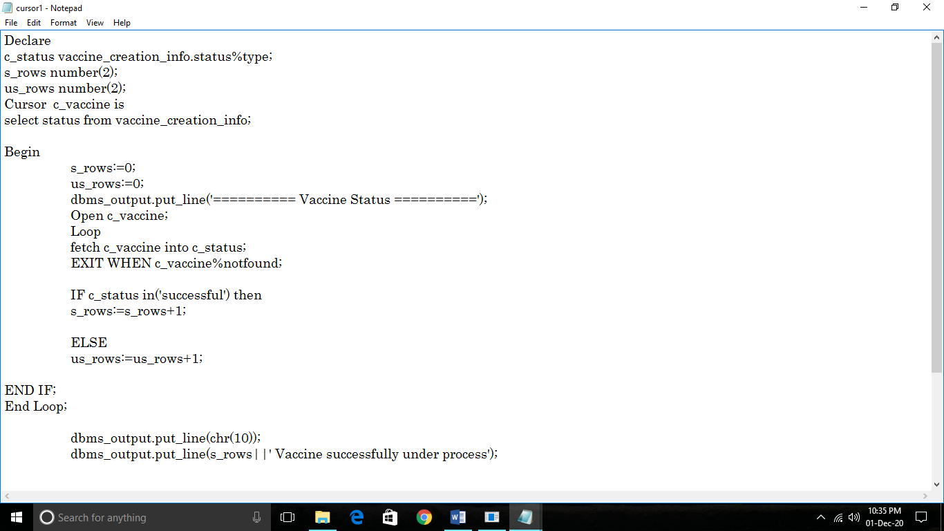

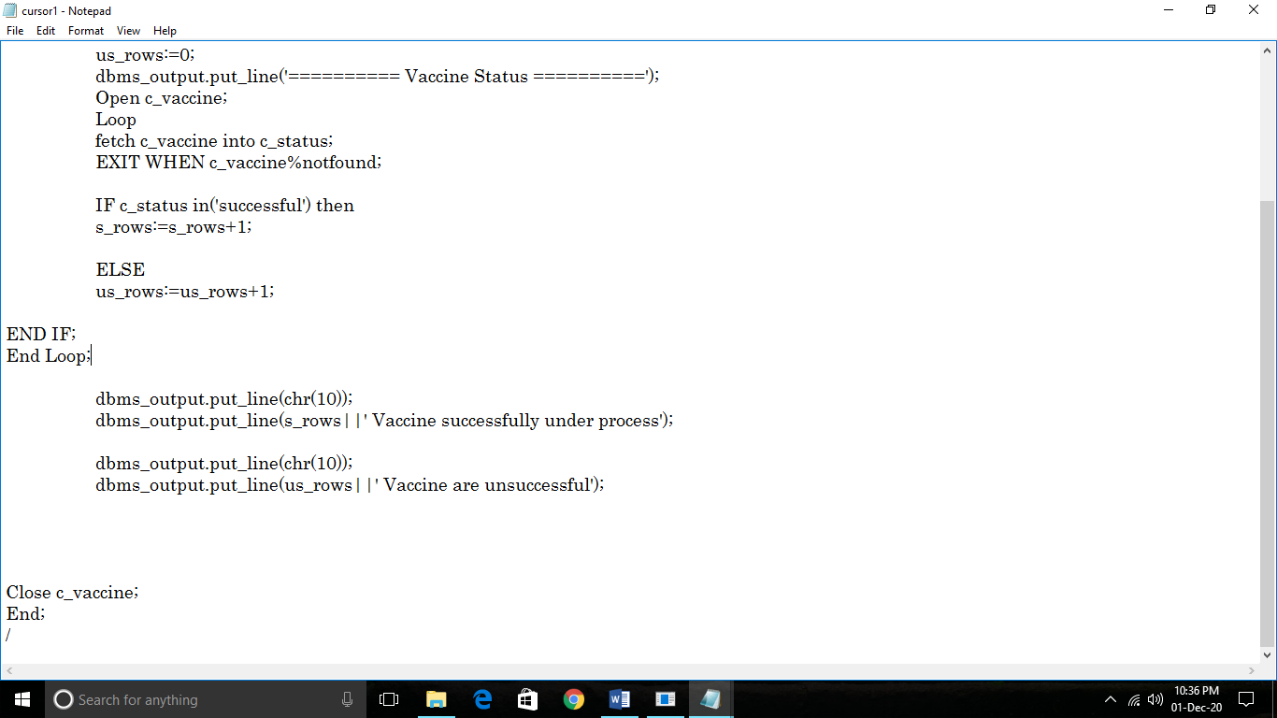

Output :

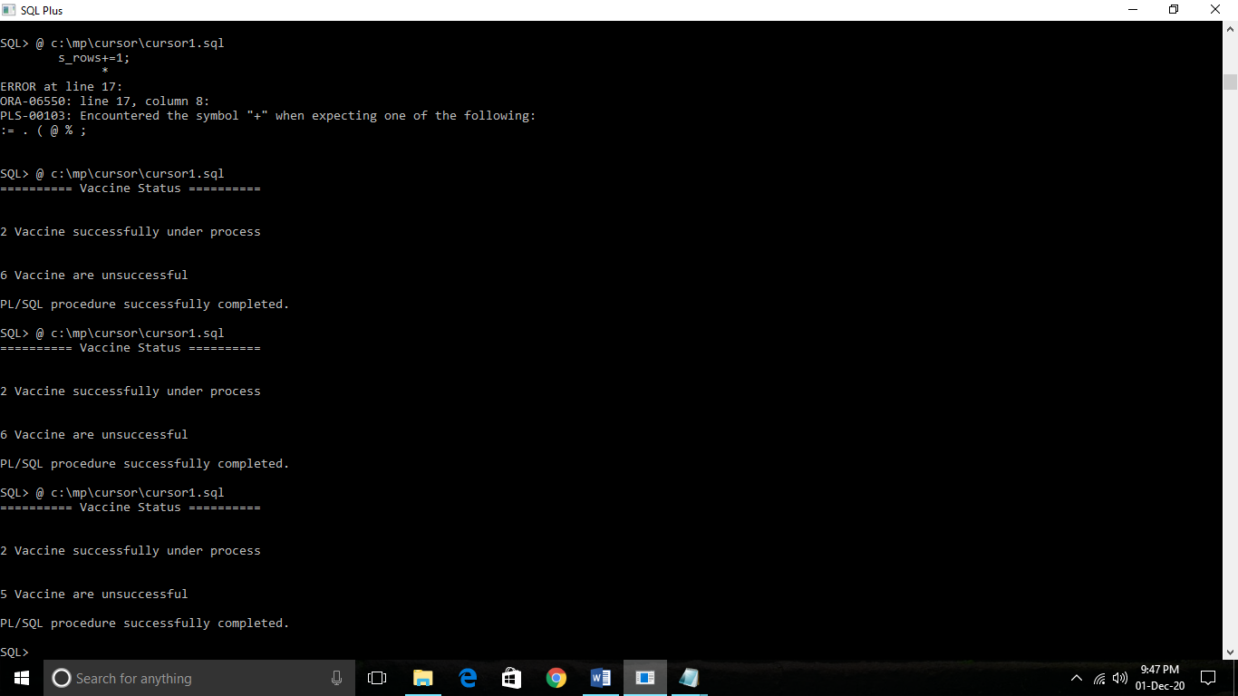

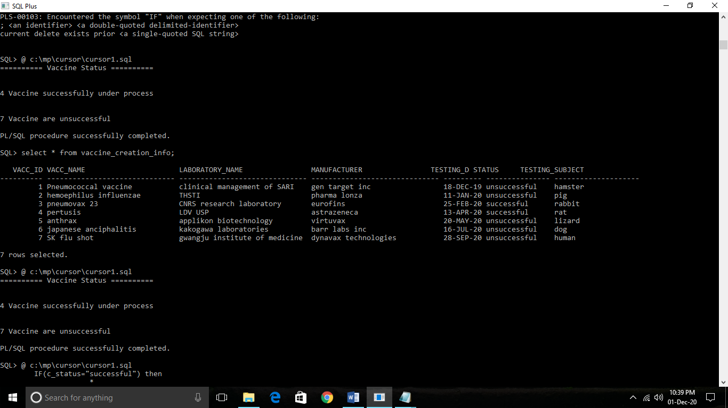

**DROP TRIGEER EG.**

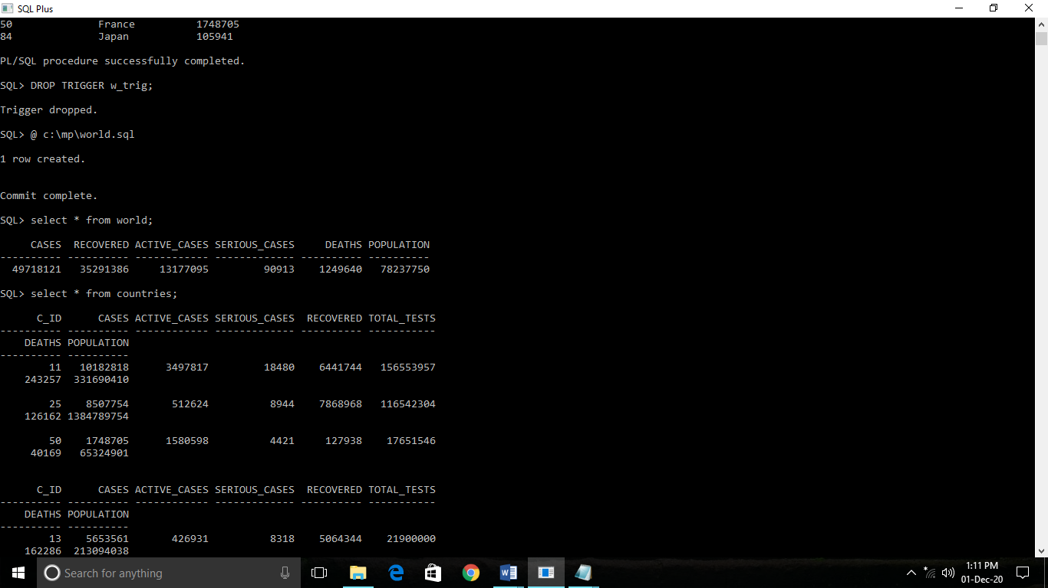

**PROCEDURE**

**CODE :**

